Access modifiers :

Step1 : create Methods with Access modifiers and calling in the main function of the same class

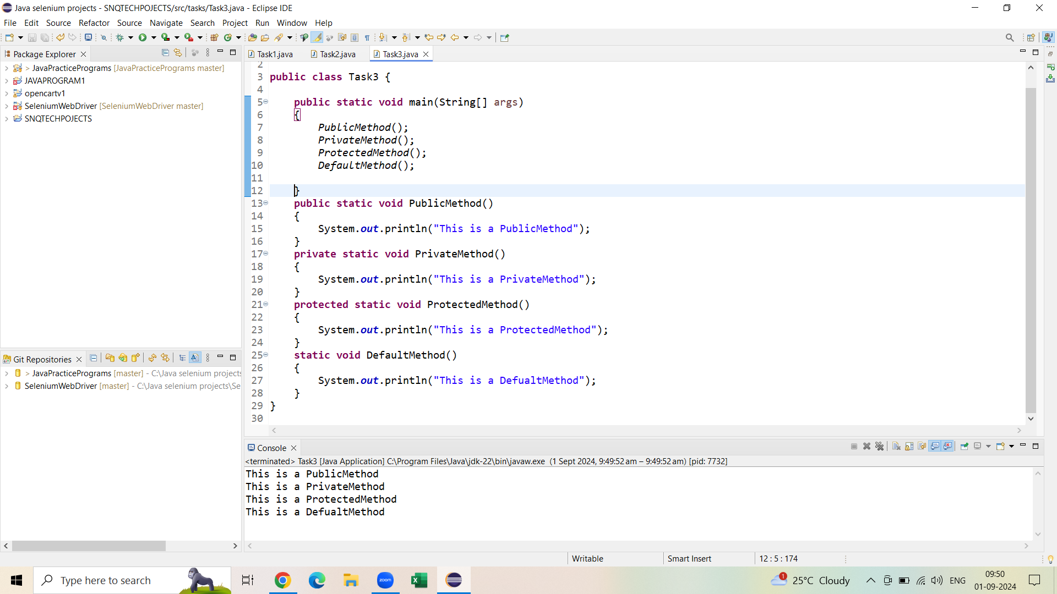

Step2 : Trying to call the methods in different class of the same package

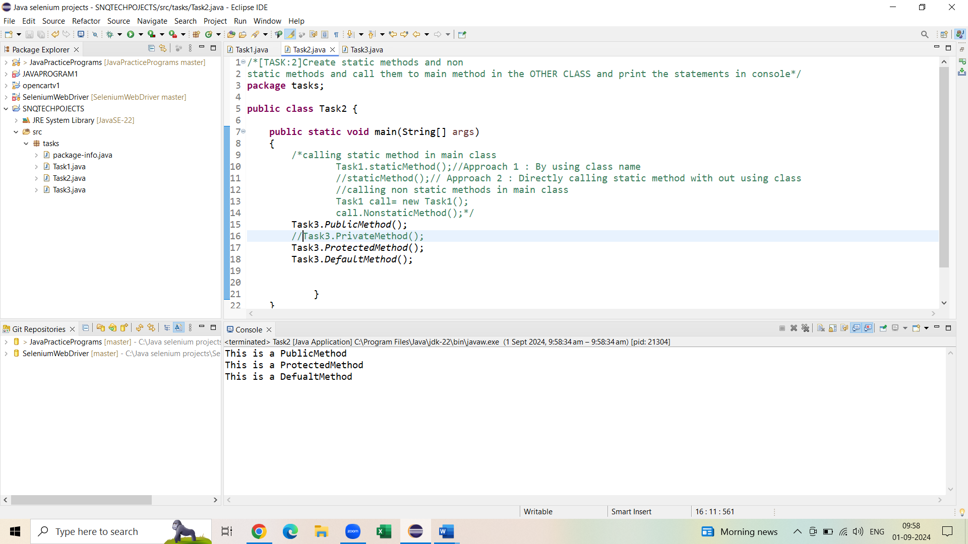

For method defined with private we will get exception when trying to access in different class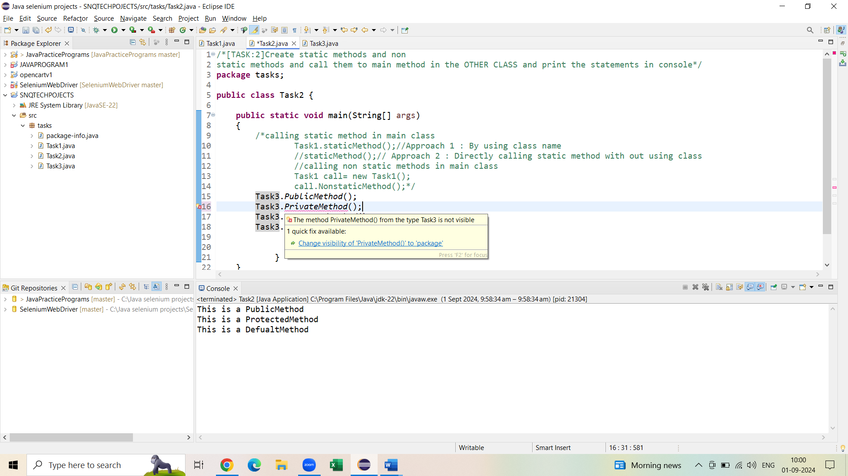

Exception :

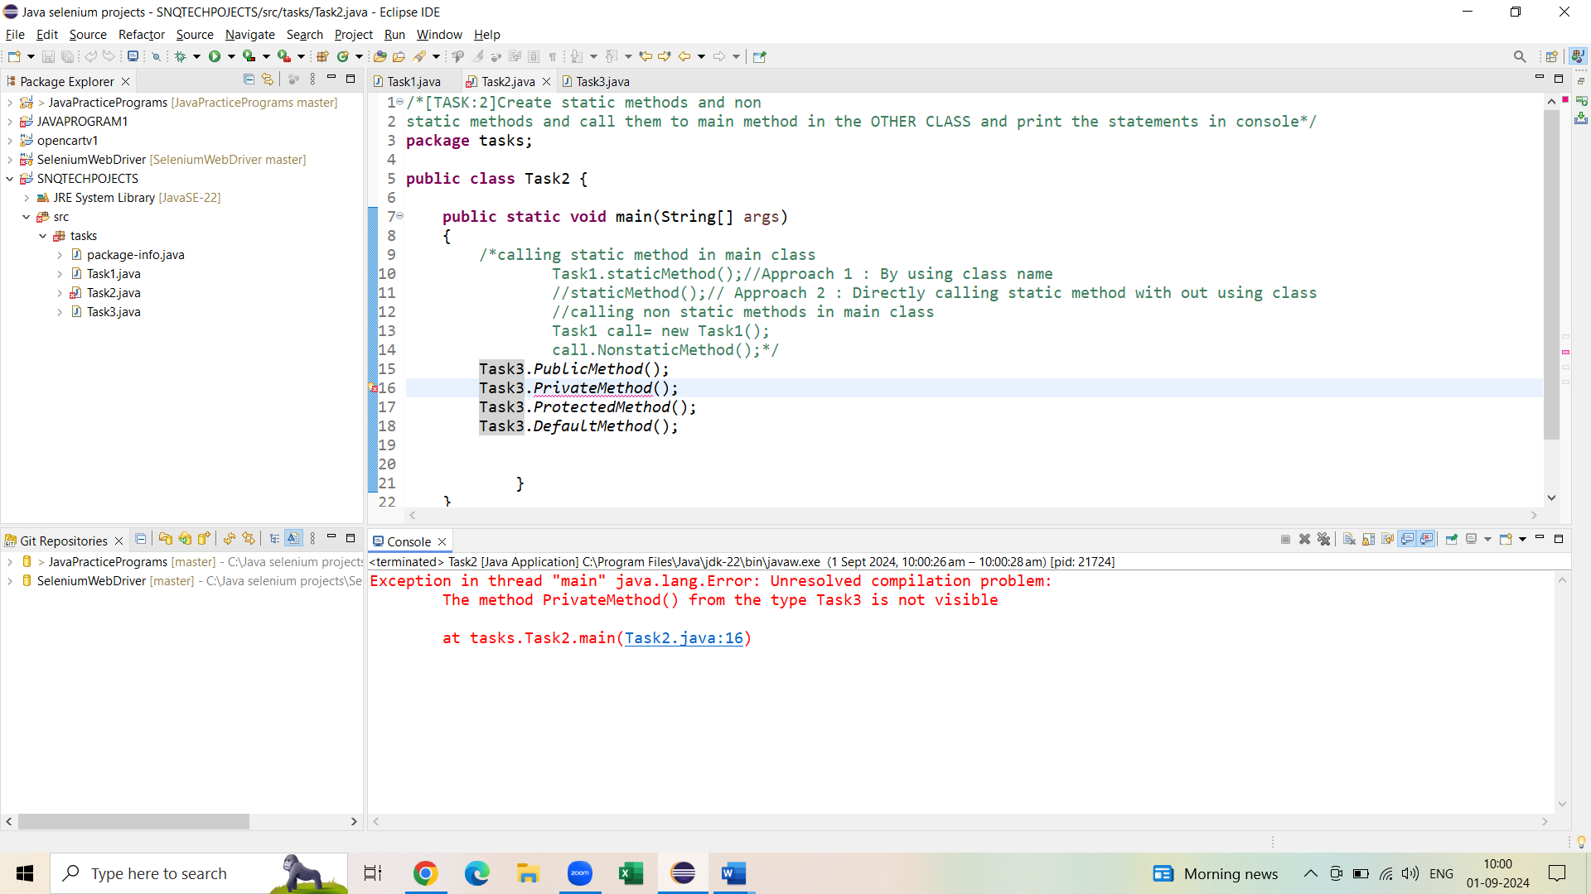

Step3: Trying to call the methods in different class of the different package

Below are the exceptions :

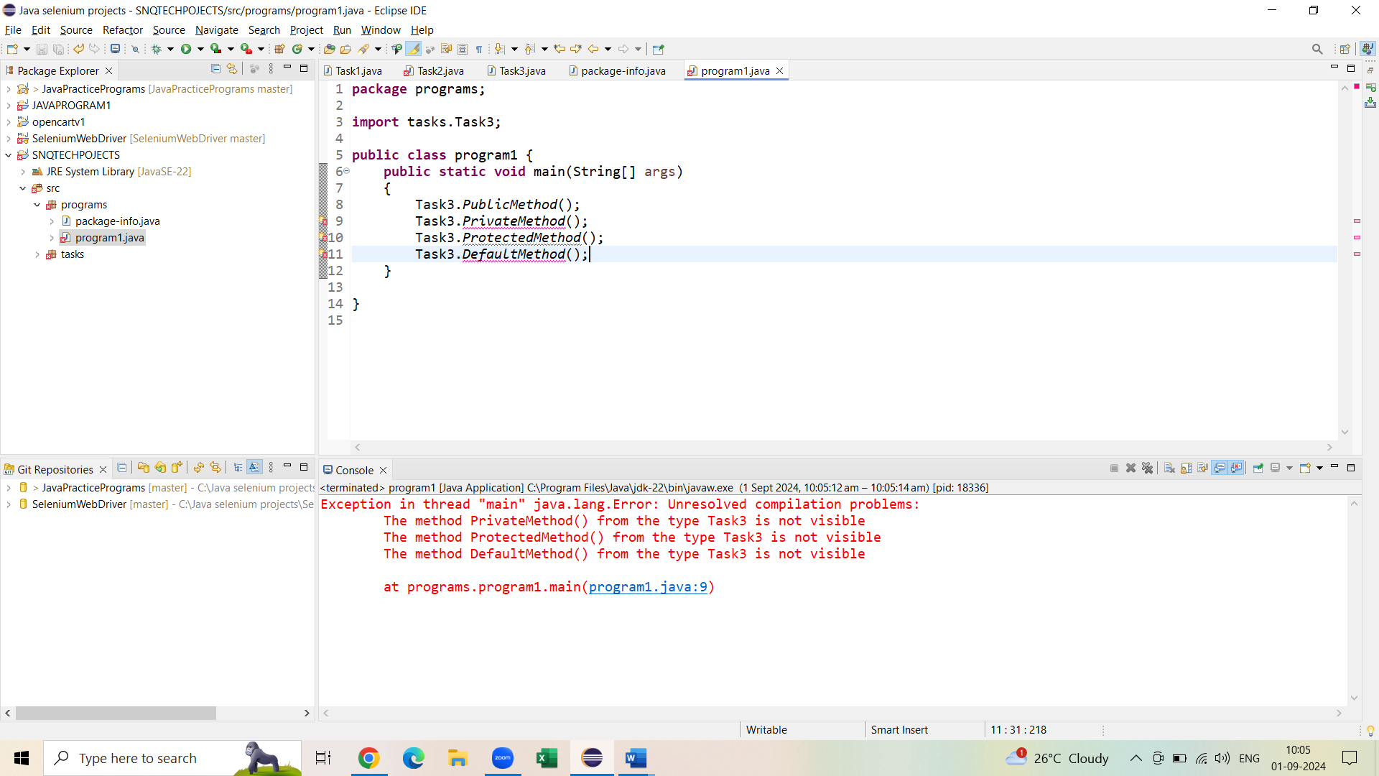

Public method can be access everywhere in the project :

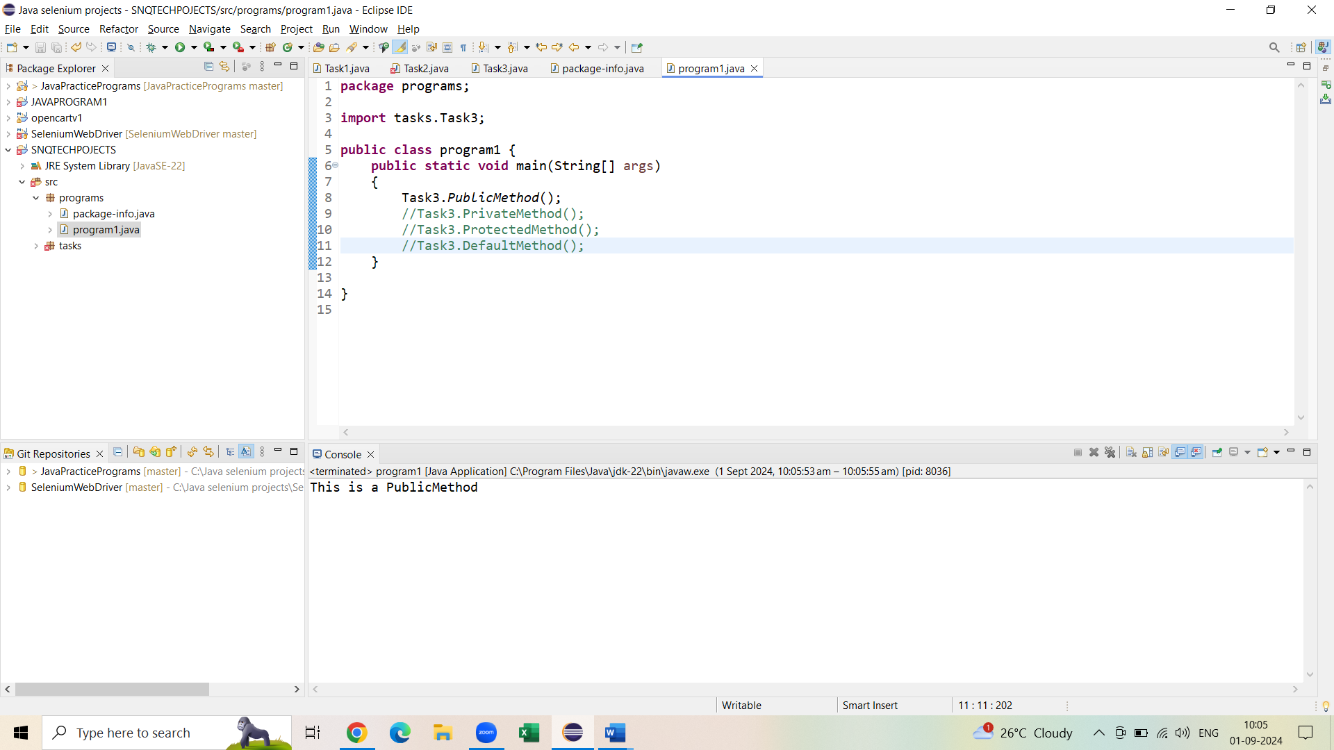

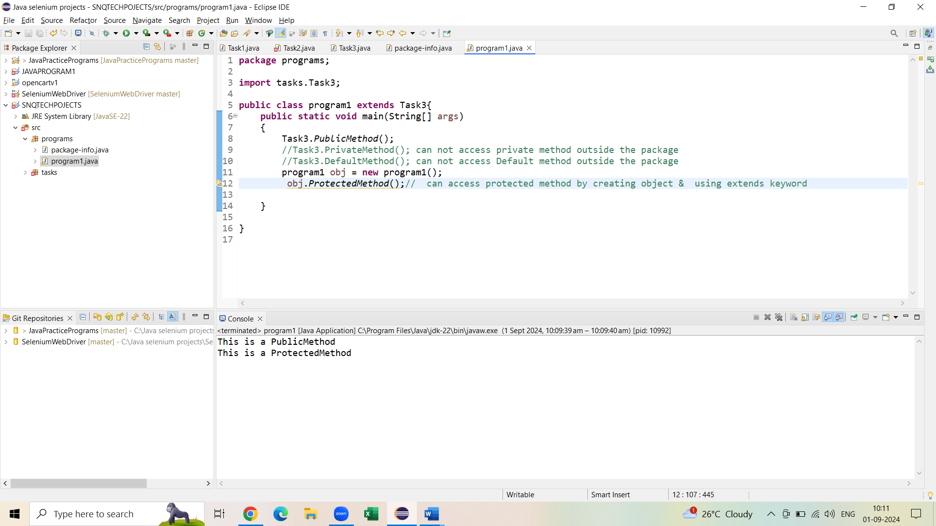

Key points :

* Methods Defined with **Public** Access Modifier keyword can be accessed anywhere in the project (In Different packages/Different classes)
* Methods Defined with **Private** Access Modifier cannot be accessed outside of the class (i.e.; 🡪It cannot be available to access in other classes with in the same package /other package)
* Methods Defined with **Default** Access Modifier

🡪can be accessed directly in different class of the same package

🡪can not be accessed out side of the package

* Methods Defined with **Protected** Access Modifier can be accessed

🡪Directly in different class of the same package

🡪Through object & **extends** in different package